**thermometer –** measures the   
*temperature* of the air

**barometer –** measures the

*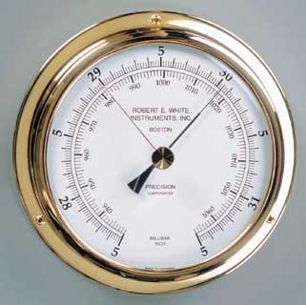air pressure*

How much the air is pushing on the Earth’s surface

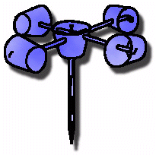**anemometer** – measures

*wind speed*

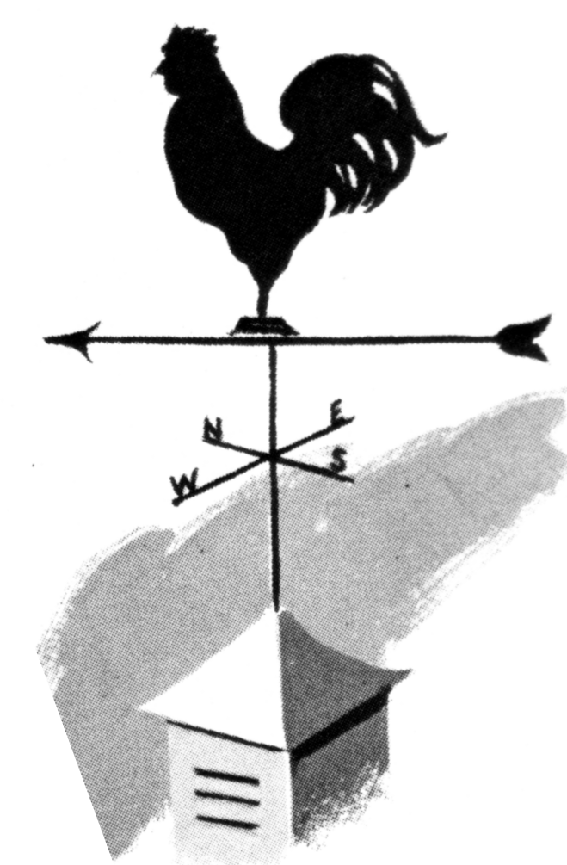

**wind vane** – measures

*wind direction*

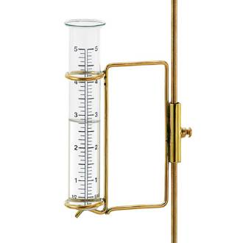**rain gauge** – measures

amount of *precipitation* that falls